Snowman
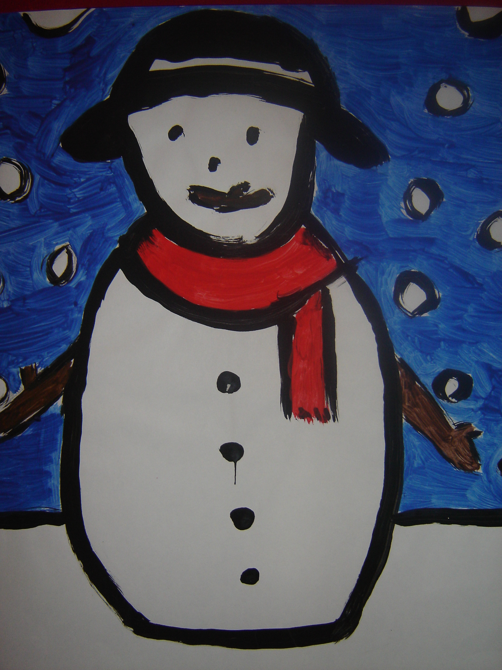

- Draw outline of snowman, including hat, scarf and arms, which fills most of the page.
- Insert horizon line roughly one quarter of the way from the bottom of the page.
- Draw outlines of snowflakes in the background.
- Paint in sky background, snowman’s hat, scarf and facial features, leaving all remaining white.
- Outline snowflakes in black.

