Christmas Lanterns
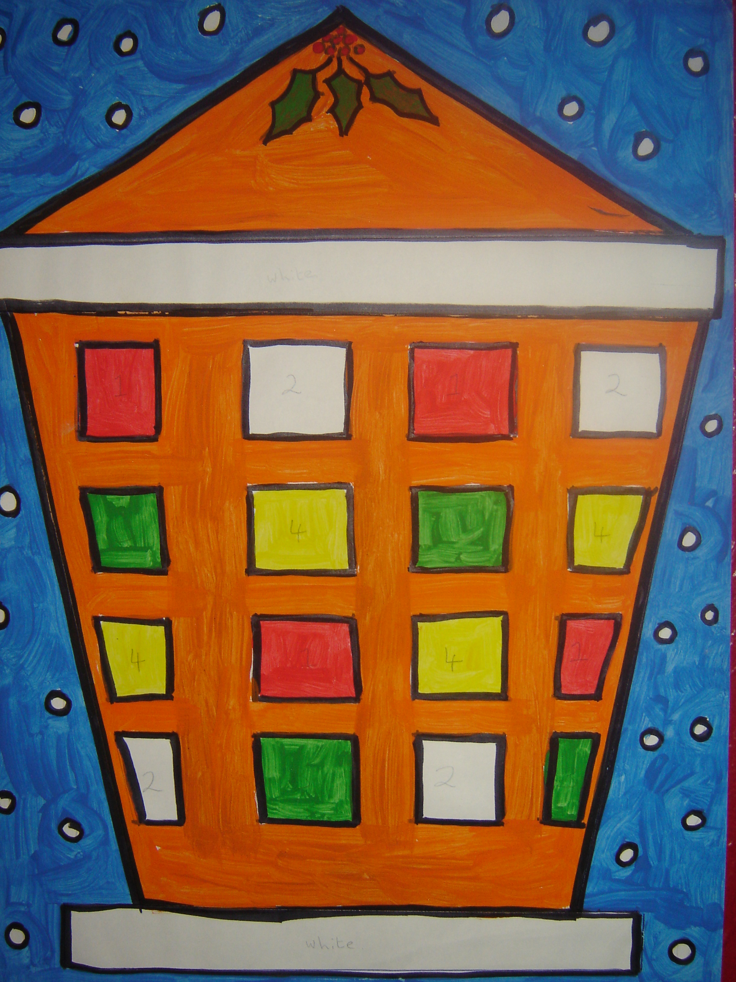

- Draw the shape of a Christmas Lantern, filling most of the page.
- Draw sixteen windows in the front of the lantern.
- Pick four different colour paints and number them one to four.
- Paint the windows of the lantern in the following pattern:
1 2 1 2
3 4 3 4
4 1 4 1
2 3 2 3
- Colour the background of the lantern in any colour not used for the windows.
- Draw circles in the outer part of the picture as falling snowflakes.
- Paint around these snowflakes using blue for a sky backround.

