Salt Dough Christmas Wreath #1
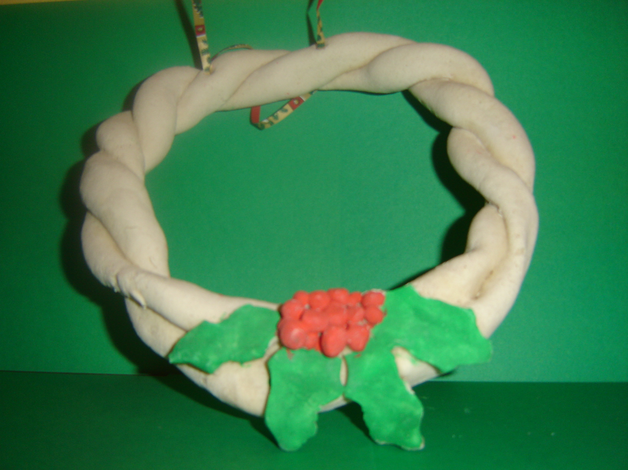
It can be useful to ask pupils to bring ingredients into school in a biscuit tin or other similar container. The wreath can then be taken home safely in this container to be oven baked. A rolling pin, pastry cutters or Christmas shapes can be useful for this lesson.

To Make the Dough:
Please note that there are many variations on this simple recipe. The advice is to experiment until you get exactly what you want.

Be warned also: this lesson can be messy! The advice is to do this lesson in a school hall where the floor can be easily cleaned as dried dough can be difficult to remove from carpet.

Ingredients
4 cups plain flour
1 cup salt
1-1/2 cups warm water (from tap)
2 teaspoons vegetable oil (optional)
(Some recipes say 2 cups of flour and one cup of salt – just experiment)

Mix the salt and flour together, then gradually add the water until the dough becomes elastic. (Some recipes call for 2 teaspoons of vegetable oil at this point.) If your mixture turns out too sticky, simply add more flour. If it turns out too crumbly, simply add more water. Knead the dough on a dry surface for about ten minutes to remove bubbles and to work out the coarseness of the salt. Knead until the dough is a good consistency.

If you want coloured dough, mix food colouring, powdered drink mix (like coffee or cocoa), or put powder paint into the water before adding it to the dry ingredients. Or you can simply paint your creations after baking. Experiment with both methods.

Baking times will vary depending on the size and thickness of the object, but baking for a couple of hours at @ 200 degrees is an average. Keep an eye on the object in the oven and if it is starting to brown cover with aluminium foil. Make sure that all of the object is hard before removing from the oven.

To Make the Wreath:
- Once the dough is made, remove three even sized balls. Using hands, roll each of the balls into a long snake like shape on the table.
- Plait the three long “snakes” together, form into a circle shape and join both ends of the plait together. The plait can be difficult to work with so it could then be placed on the lid of the biscuit tin.
- Using a rolling pin, roll out some dough. Cut out some holly leaves and attach to the wreath, covering the join of the plait.
- Roll out some small balls of dough and attach to the wreath beside the holly. These represent the holly berries.
- Use a cocktail stick to make two holes at the top of the wreath to hang it when dry.
- When dry, the wreath and/or the holly and berries can be painted.
- It can also be useful (but not really that necessary) to paint the wreath with clear varnish.

