Salt Dough Christmas Tree
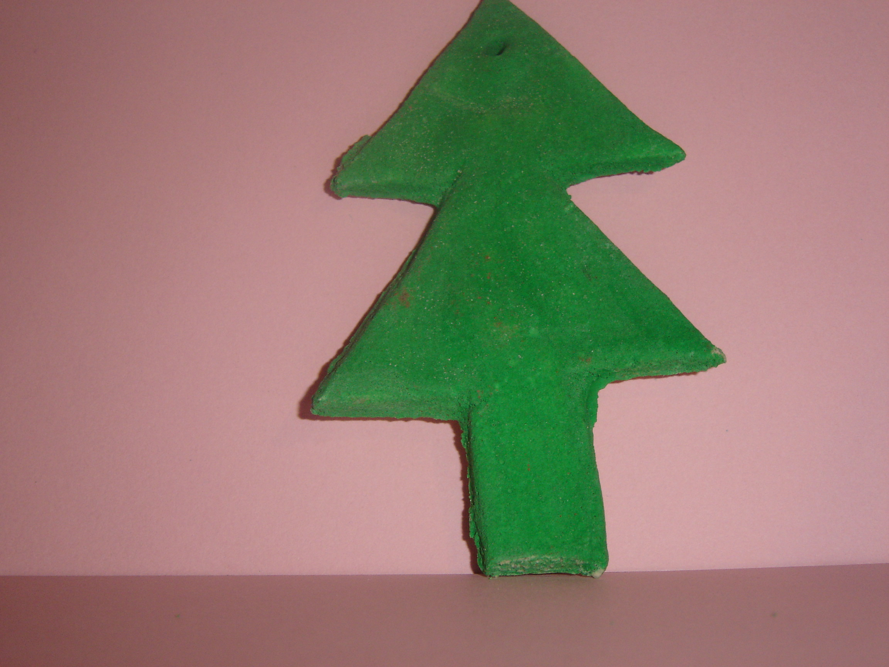
- Make salt dough as per instructions for Salt Dough Christmas Wreath #1.
- Use a rolling pin to roll out some dough.
- Using a blunt knife, cut out a Christmas tree shape.
- Using a cocktail stick, make a hole near the top of the tree.
- Bake object in oven as per instructions.
- When dry, the tree can be painted.
- It can also be useful (but not really that necessary) to paint the holder with clear varnish.
- Loop some Christmas ribbon through the hole at the top of the tree and hang as a decoration on the Christmas tree.

