Crib Silhouette
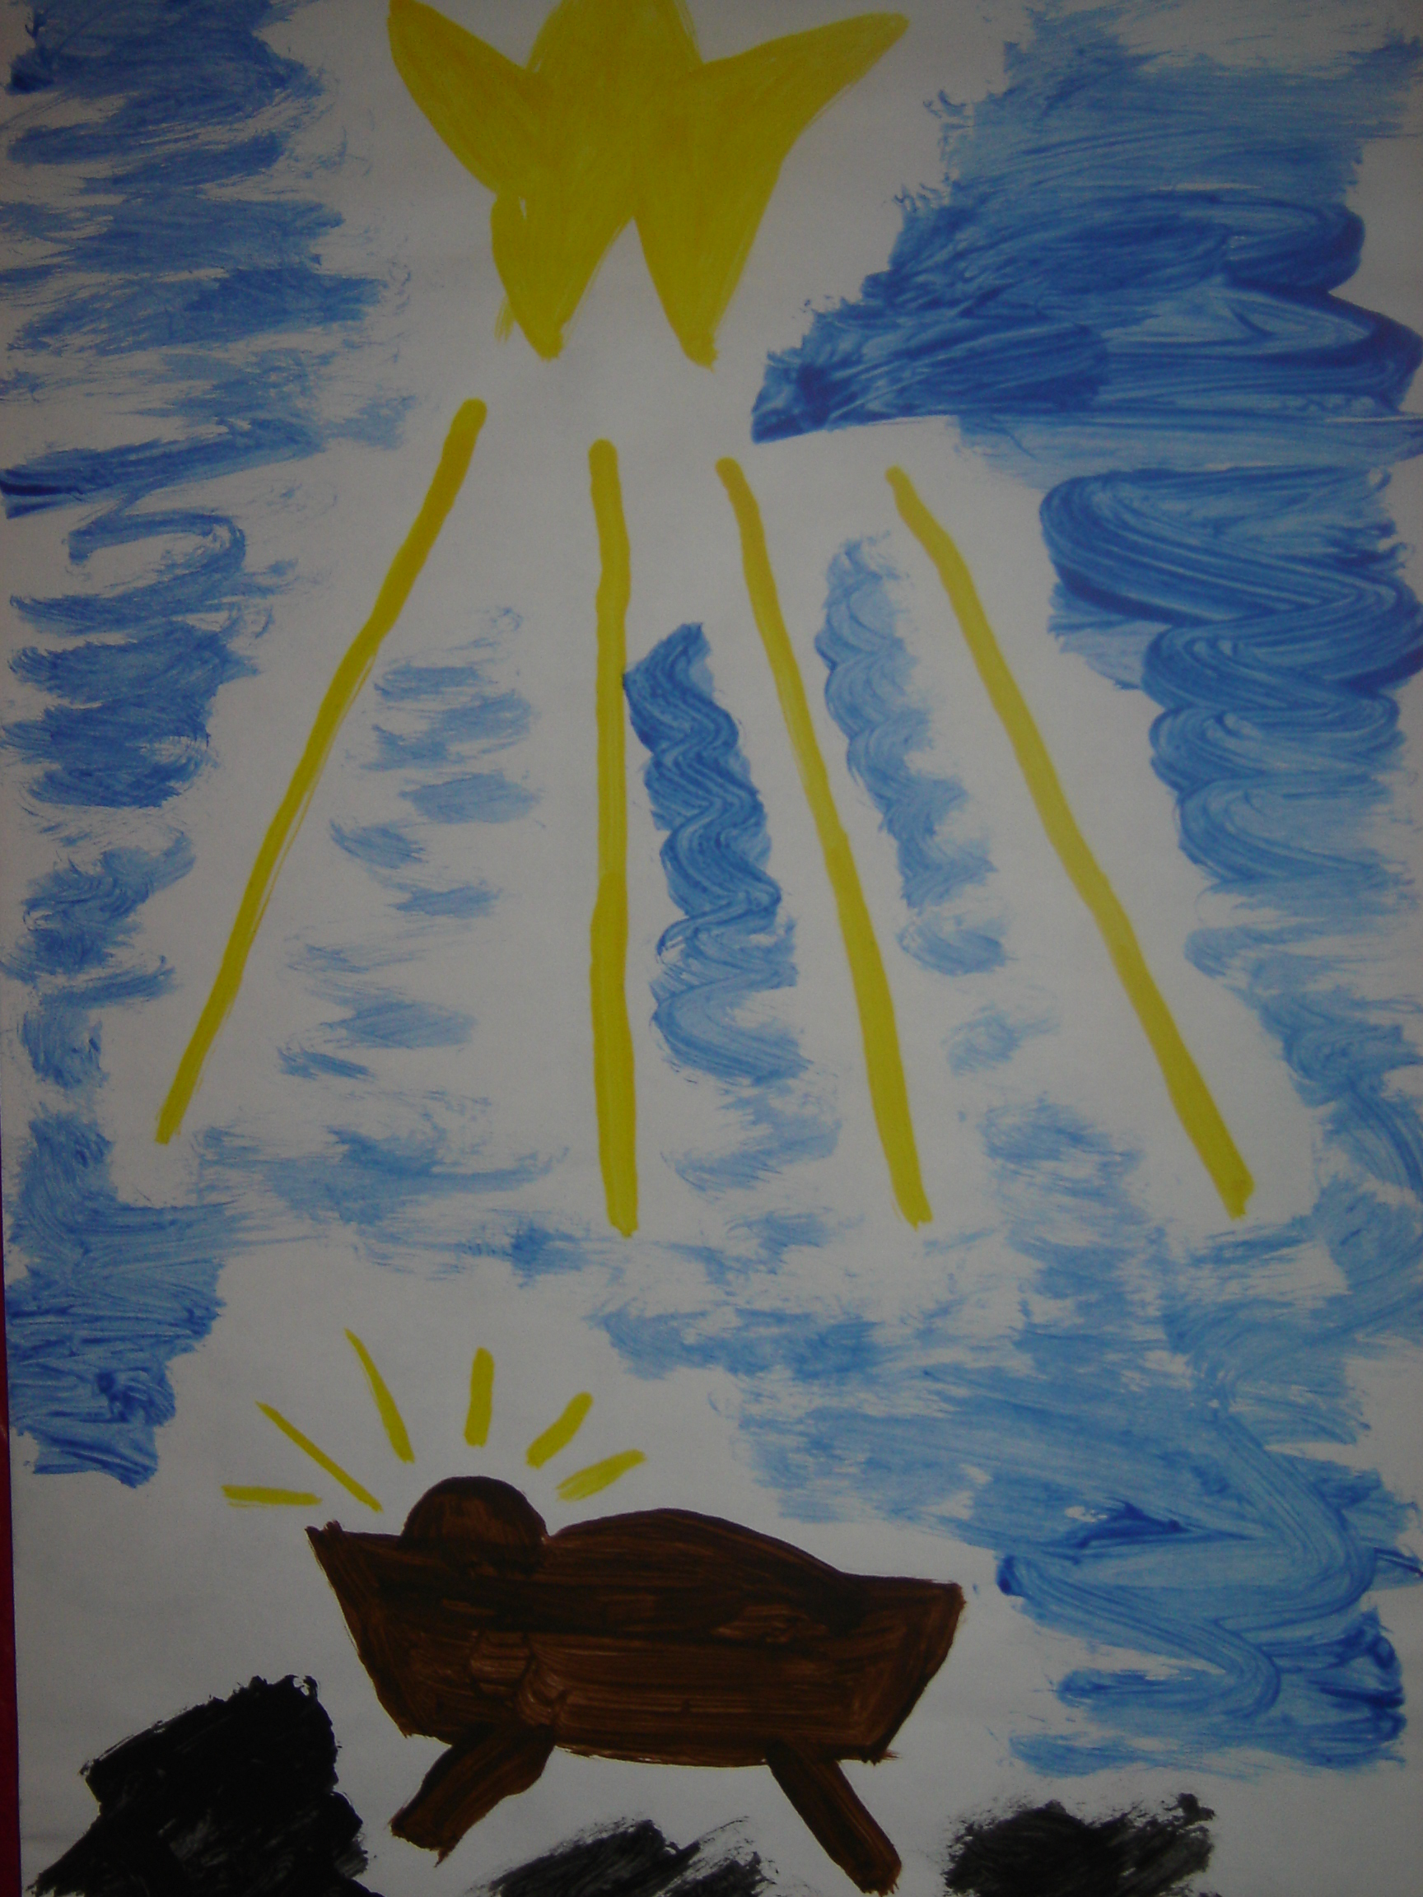

- Paint a silhouette of the baby Jesus in the manger using black poster paint or other dark colour.
- Paint rays of yellow around the head of the Baby Jesus.
- Paint a large yellow star in the centre of the top of the page.
- Paint rays of yellow from the star down towards the manger.
- Paint the space in between the star rays with blue for the sky. This does not need to be exact to look well.

Use this idea to paint silhouettes of Christmas or any other scenes.

