Christmas Wrapping #2
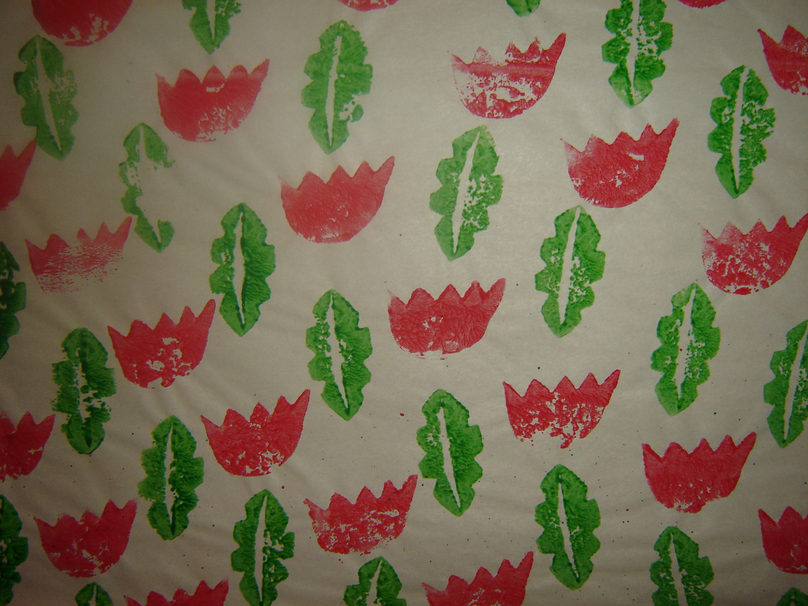
- Use newsprint for this visual art activity. Potatoes are used for the printing.
- This is quite simple to do. Use the Christmas colours of red and green.
- Explain the idea of pattern in wrapping paper or wallpaper, how the pattern is always repeated in “drop brick” pattern i.e. like the bricks on a wall.
- For safety, the teacher or parents should cut the potatoes into shape for the printing. Any shapes can really be used for this activity as the red and green colours suggest Christmas.
- Dip the first potato into the green paint and print a repeated pattern.
- Dip the second shape into the red paint and print in the spaces.
- Don’t forget that half shapes can be used at the edge of the paper to suggest that the paper has been cut from a larger piece of paper and that the pattern has been continued.

