Christmas Wrapping #1
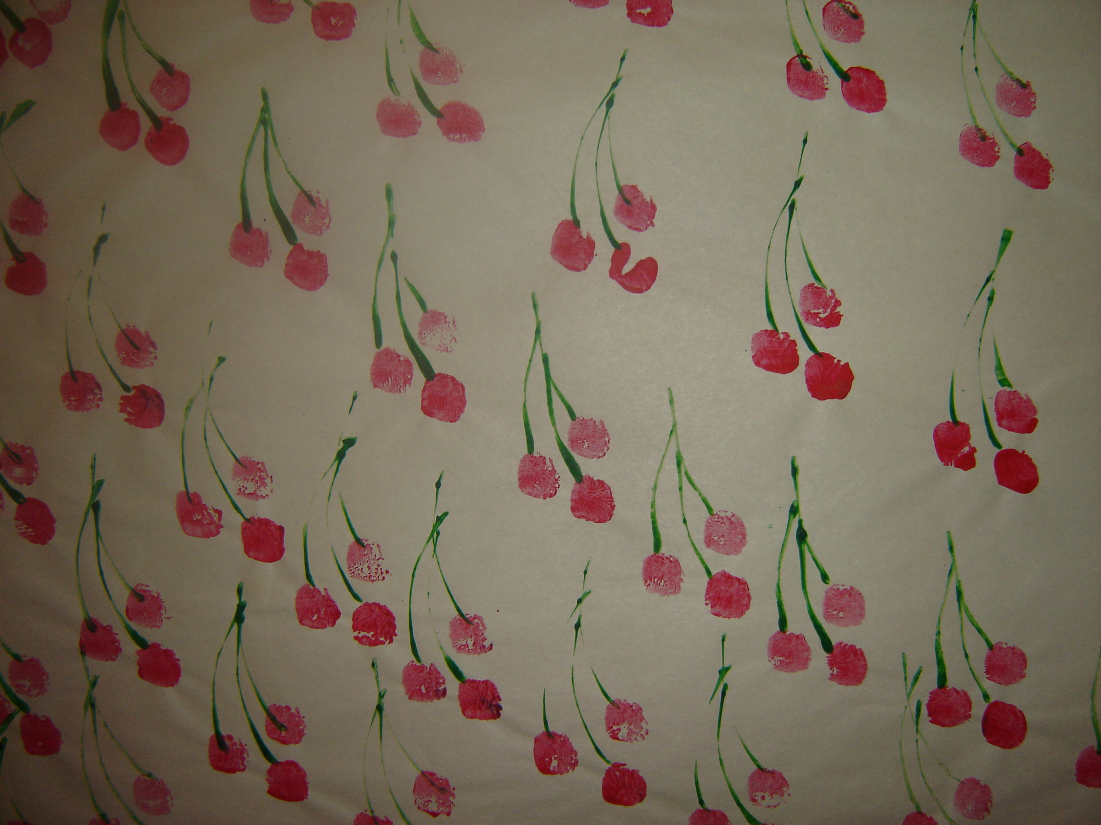
- Use newsprint for this visual art activity.
- This is quite simple to do. Use the Christmas colours of red and green.
- Explain the idea of pattern in wrapping paper or wallpaper, how the pattern is always repeated in “drop brick” pattern i.e. like the bricks on a wall.
- Use a finger dipped into red paint to print the red berries.
- Use the edge of a piece of cardboard dipped into green paint to print the stems.
- Don’t forget that half shapes can be used at the edge of the paper to suggest that the paper has been cut from a larger piece of paper and that the pattern has been continued.

