Christmas Cottage
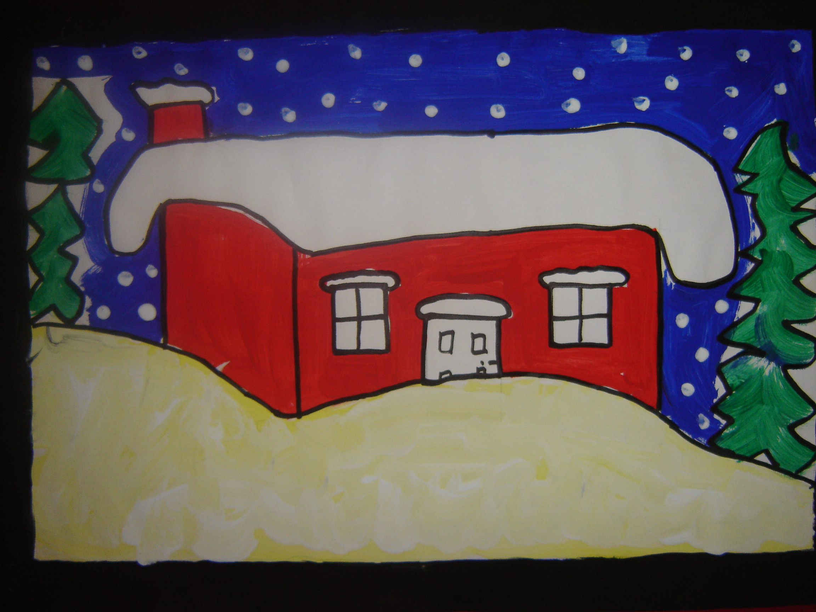

- Draw outline of cottage in the centre of the page with a snow covered roof.
- Draw outline of snow drifts covering the front of the cottage.
- Draw outline of trees in the background or sides.
- Paint the cottage in a rustic or Christmas colour. (red works well with the green of the trees for Christmas)
- Paint sky blue in the background and paint the trees green.
- Leave the roof and snow drifts white for the snow. (you can add a touch of yellow to white paint if you want to get more texture into the snow)
- Paint a black frame on the picture if desired.

