Christmas Lollipop Art #2
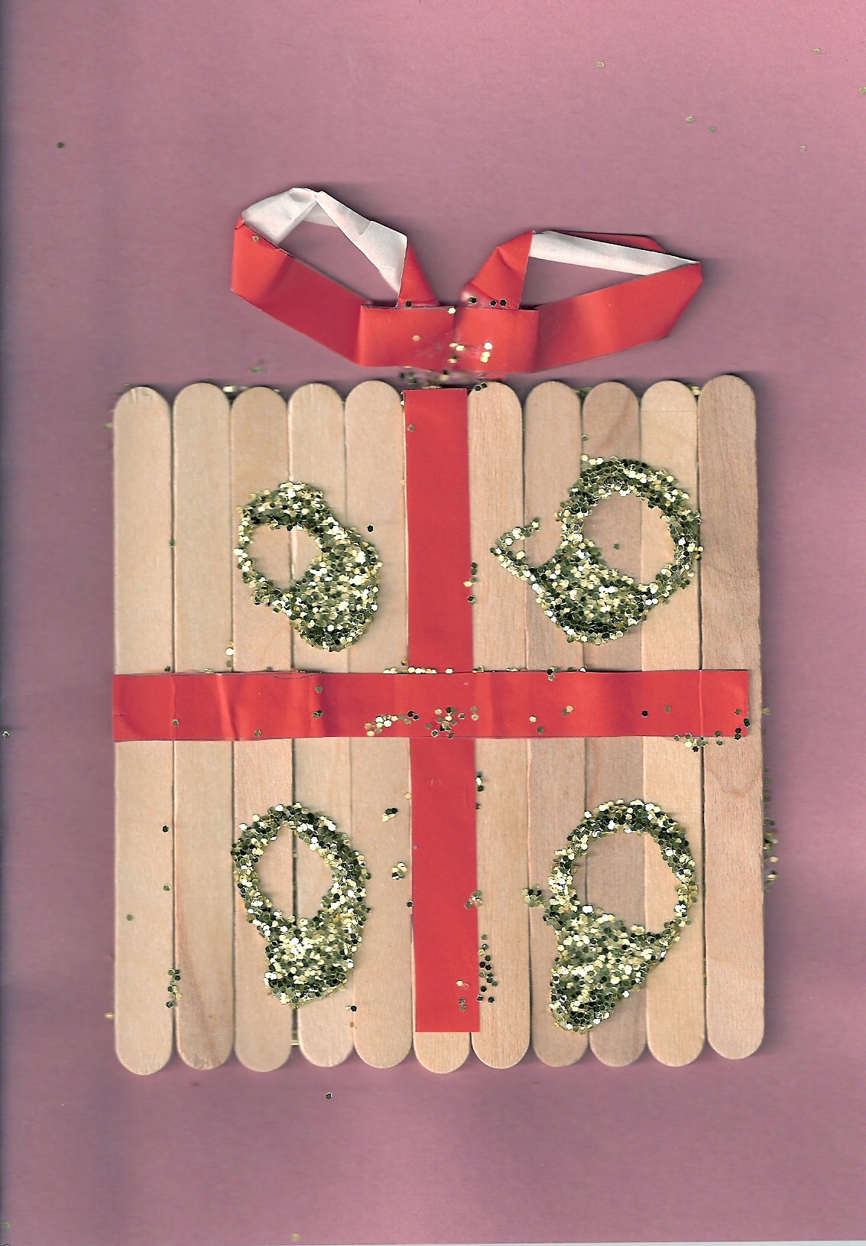

- For this really easy visual art lesson you will need lollipops, glue, card, paper (or ribbon/material) and glitter.
- Select any colour A4 card and fold in half.
- To design the gift on the cover, glue as many lollipop sticks onto the centre of the card to make a square shaped gift. (the pictured example took eleven sticks)
- Stick on strips of coloured paper or ribbon in a cross on the front of the gift. Make a ribbon of paper (or use ribbon material) and stick the ribbon on top of the gift.
- Squeeze some glue straight from the bottle, making a pattern on the front of the gift.
- Sprinkle any colour glitter over the wet glue and allow to dry.
- When the glue is dry, shake off and save the excess glitter.

